

**US Army Corps of Engineers**

**Afghanistan Engineer District**

AED Design Requirements:

Oil/Water Separators

Various Locations, Afghanistan

January 2010

**TABLE OF CONTENTS**

AED DESIGN REQUIREMENTS FOR

OIL/WATER SEPARATORS VARIOUS LOCATIONS, AFGHANISTAN

Section Page

**1. General 1**

**2. Oil/Water Separators 1**

**3. Types of Oil/Water Separators 1**

**4. Conventional Separators (API) 1**

**5. Parallel Plate Separators 2**

**6. Oil Collection 3**

**7. Design of Oil/Water Separator Systems 3**

a) Wastewater Characterization 3 b) Site Considerations 4 c) Establishing the Design Flow 4 d) Pretreatment for Grit Removal 5

**8. Design of Oil Water Separator Systems 5**

a) Parallel-Plate Separators 5 b) Conventional Separators 5

**10. Design Example 6**

**11. Central Vehicle Wash Facilities (CVWF) 7**

**12. Sludge Removal and Disposal 7**

**13. Guidance Documents 7**

**14. As-Builts 7**

Figures

Figure 1. Conventional Gravity Separator 2

Figure 2. Downflow Parallel-Plate Separator 3

Figure 3. Oil Water Separator Layout 6

**1. General**

The purpose of this document is to provide requirements to Contractors for any project requiring the design and construction of oil/water separators.

**2. Oil/Water Separators**

Oil/water separators are devices commonly used to separate oily waste products from wastewater streams. They are typically installed in industrial and maintenance areas such as aircraft and vehicle maintenance and washing and other activities involving petroleum, oil and lubricants (POL) to separate oils at low concentrations from wastewater.

**3. Types of Oil/Water Separators**

There are three predominant types of oil/water separators: Gravity separators (conventional gravity separators and parallel plate gravity separators) and flotation separators. The overwhelming majority of oil/water separators used are conventional gravity separators. Gravity separators use a process that relies on the different densities of oil, water, and solids for successful operation. The wastewater is fed to a vessel sized to provide a quiescent zone of sufficient retention time to allow the oil to float to the top and the solids to settle to the bottom. Gravity oil/ water separators come in two configurations: conventional separators such as those designed in accordance with guidelines established by the American Petroleum Institute (API) and parallel plate separators. The primary types of oil/water separators described in this section are intended for the removal of free and emulsified oils and greases, usually as a pretreatment method before discharge to the sanitary sewer or septic system.

**4. Conventional Separators (API)**

A typical conventional separator system is shown in Figure 1. The separator itself has three chambers separated by baffles: an influent chamber, the main separator chamber, and an effluent chamber.

The influent chamber removes free oil that has already separated from the oil/water mixture during conveyance to the unit. Two baffles separate the influent chamber from the larger, main settling chamber. The upper baffle is placed at the top of the water level and extends three quarters of the way to the bottom. It prevents the floating oil and scum from entering the main chamber, and allows it to be skimmed off through an overflow pipe. The lower baffle extends from the bottom and directs the wastewater to the top of the main chamber and to prevent short-circuiting.

In the main separator chamber, the oily wastewater flows from one end to the other under quiescent conditions. The wastewater velocity is kept very low, typically less than 0.9 m/min to prevent turbulent mixing. For flat-bottom chambers, removal of settled solids is typically accomplished by taking the chamber out of service; the chamber is drained and accumulated solids are removed either manually or by a vacuum truck. If the floor is sloped, the solids can be removed from the hopper or V-bottom trough by pumping or gravity discharge while the unit is still in service. An oil-skimming device should be provided at the end of the separation chamber. The rotatable, slotted-pipe skimmer is the most common type. Other oil-skimming devices include belt skimmers and floating skimmers. The oil collected by the skimmer is discharged to a used oil holding tank.

The effluent chamber is also separated from the main chamber by upper and lower baffles. Wastewater flows under and over the baffles into the effluent chamber. From the effluent chamber, the treated water can be discharged to the sewer system or to additional treatment if necessary.

**5. Parallel Plate Separators**

Figure 1. Conventional Gravity Separator

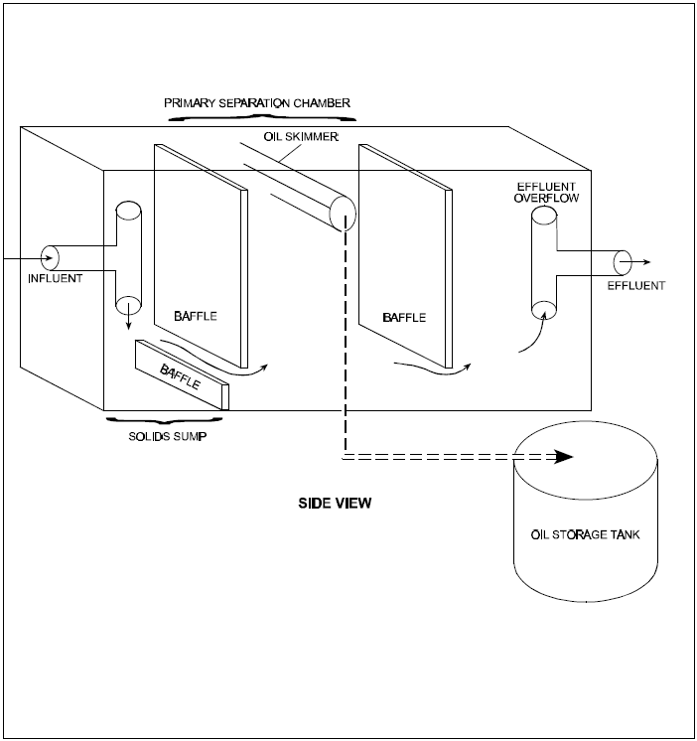

A typical parallel-plate separator system is shown in Figure 2. Parallel-plate separators function on the same principles as conventional gravity separators, but they require less space. Incorporating an array of closely spaced parallel plates within the separator chamber increases the surface settling area, allowing the overall size of the unit to be reduced. Flow through a parallel-plate unit can be two to three times that of an equivalently sized conventional separator. The oil is removed by passing the wastewater at laminar velocity through the pack of closely spaced plates, which are constructed at various inclines ranging from 45 to 60 degrees. The oil droplets rise vertically until they contact the underside of the plates, where the oil coalesces and continues to gradually move upward along the underside of the inclined plates. Eventually, the floating oil is collected at the surface of the tank.

The plates aid in separation in the following ways: Prevent shout-circuiting of the oily waste. Increase the effective settling area.

Enhance contact/agglomeration of oil particles.

The plates may be made of an oleophilic (oil attracting) material, such as polyethylene, fiberglass, or nylon to promote coalescence of oil droplets. For this reason, the units are sometimes referred to as coalescing plate separators. Parallel or coalescing plate separators are usually recommended only for light oil loadings when a higher level of oil removal is required, when the wastewater stream contains minimal solids concentrations, and when the facility is committed to the additional maintenance procedures required keeping the coalescing pack free of debris. The plates may also be constructed in a corrugated configuration with alternate troughs and ridges, such as in the Corrugated Plate Interceptor (CPI). It should be noted that polypropylene is not recommended for

use in coalescing plates because it has been found to have excessively strong oleophilic properties that prevent oil droplets from detaching and floating to the surface.

In parallel-plate separators, solids settle to the bottom and are collected in a sludge well. From the well, sludge is pumped or withdrawn by gravity. If sludge transfer is by gravity displacement, an automatic valve is usually provided.

Figure 2. Downflow Parallel-Plate Separator

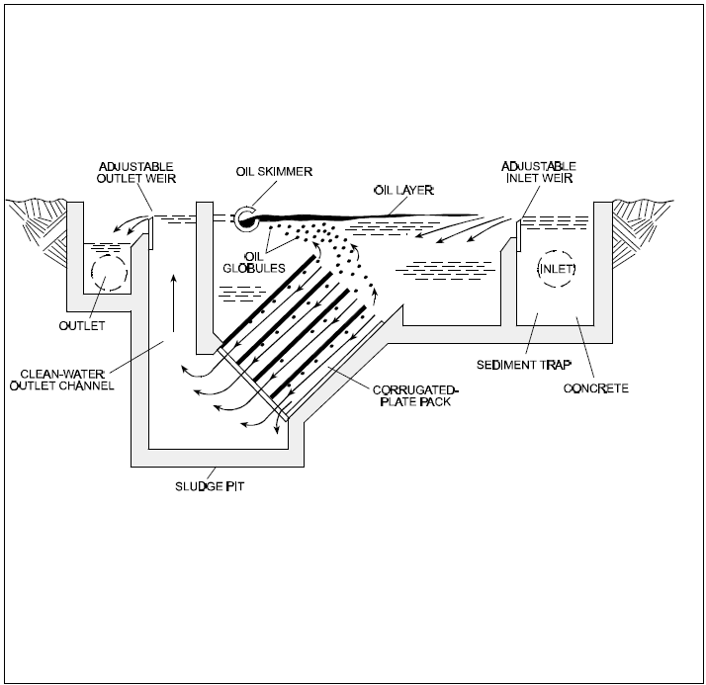

**6. Oil Collection**

A tank should be provided for collection of used oil collected by the skimmer. The tank should be designed as an integral part of the oil/water separator system and should also be designed so that confined space entry is not required for operation and maintenance.

**7. Design Considerations for Oil/Water Separator Systems**

Design of conventional and parallel-plate oil/water separator systems requires proper characterization of the wastewater, establishment of the design flow and required effluent quality, sizing of the separator, and proper flow attenuation/flow equalization of the influent. Sludge disposal and used oil disposal also needs to be properly considered. The designer should work to identify the user’s needs and the capability of any vendor-supplied equipment. These aspects of system design are discussed below.

**a) Wastewater Characterization.** If possible, the wastewater to be treated should be analyzed for total oil and grease, including determination of the free, emulsified, and dissolved oil fractions. As indicated previously, although oil/water separators are designed to remove free oil, they also remove solids. Therefore, the solids content of the wastewater is important in overall system design. Analyses should include TSS, volatile suspended solids (VSS), and settleable solids. These analyses will help determine the amount and frequency of settled materials that will need to be removed from the bottom of the oil/water separator and the advisability of providing grit removal upstream of the oil/water separator.

Other wastewater characteristics important in the design of oil/water separators are the specific gravities of the oil and water phases and the absolute viscosity of the wastewater, both at the minimum design temperature. Wastewater temperature and pH have a major impact on the efficiency of the separator, with poorer separation occurring at lower temperatures and high pH values. Separators are not designed to remove pollutants such as phenols, solvents, and heavy metals. These pollutants should be addressed by the use of pollution-prevention techniques. If the wastewater characteristics cannot be determined through testing, the facility should refer to the general wastewater characteristics for similar facilities as provided in Section 4 of MIL-HDBK-

1005/17.

**b) Site Considerations.** The oil/water separator should be designed to be readily accessible for maintenance and inspection, including access for a vacuum truck or other oil- and grit-removal equipment. Visual inspection and the ability to probe for solids levels are critical to good operation. Aboveground units are the easiest to access for maintenance and inspection; however, they may require pumping of the wastewater, which may cause emulsification of oils.

Below grade systems have the advantage of providing greater temperature consistency, especially in cold temperature climates. However, below grade separators with only manhole access are difficult to maintain and should be avoided. When below grade installations are necessary, they should preferably be located within an accessible vault for ease of operation and maintenance. If buried, units should have ample access points or open tops for inspection and cleaning, and should be installed with a double liner and leak-detection system.

**c) Establishing the Design Flow.** The efficiency of separation also decreases when flow exceeds the design capacity of the separator. Therefore, the design flow should be based on the maximum flow rate to be treated, including the addition of any future oily wastewaters and stormwater runoff. In determining peak flow rates, variations between shifts and daily and seasonal variations should be considered. Flow rates should be measured where the wastewater generating process already

exists, or accurately estimated where it does not.

In some cases, establishing production-based wastewater generation rates may be useful for projecting future flows. For example, the maximum flow expected from an aircraft washing facility may be estimated from the expected washwater per aircraft multiplied by the maximum number of aircraft to be washed in a given period. If unit wastewater generation rates from another facility are used, differing conditions should be accounted for, such as differences in the type and size of aircraft and washing procedures.

Where high flows of short duration are to be handled, alternatives to constructing a larger separator include:

Providing flow equalization at an upstream grit basin.

Providing flow equalization within the oil/water separator itself by operating the unit in batch treatment mode (emptying after each batch).

Providing curbing and covering of outdoor washracks to exclude stormwater.

Some installations have installed a manually controlled valve on washrack drains to allow stormwater to be diverted to a storm drain during rainfall periods, but such valves are discouraged because they are prone to be left open and allow washwater to be discharged.

**d) Pretreatment for Grit Removal.** A separate basin to remove grit should be provided upstream of the oil/water separator for wastewaters with a high suspended solids concentration. The design should be based on gravity separation of grit with a minimum detention time of 5 minutes at the maximum rate of flow. Larger basins may be used if the grit removal basin is also designed as a flow equalization basin. In either case, access should be provided for a truck with suction equipment to periodically remove grit. In large systems, the use of a ramp at one end of the basin may be considered if the material to be removed is primarily sand and readily dewaterable. Mechanical grit removal equipment should not be provided because it requires extensive maintenance.

**8. Design of Oil Water Separator Systems a. Parallel-Plate Separators**

Parallel-plate oil/water separators are furnished as pre-engineered, factory-assembled units. As

such, designs vary by manufacturer, and vendor experience must be used in unit sizing and selection. In general, however, the parameters and procedures used for the design of parallel-plate separators are the same as for conventional separators.

The perpendicular distance between plates should range from 2 to 4 cm, and the angle of plate inclination from the horizontal should typically range between 45 and 60 degrees. Wider plate spacing and steeper plate inclination generally reduces maintenance and improves performance but

adds to cost. Manufacturers’ claims of settling area should be checked because some manufacturers incorrectly count both sides of the plates when calculating the effective surface area for their

products. Settling area and detention time are key variables that may be used to compare competing

equipment.

Accessible placement of the oil/water separator is particularly important for parallel-plate separators, which may require frequent cleaning. Removal for cleaning with high-pressure cleaning equipment is the procedure of choice. If cleaning in place is used, a hose connection and proper provisions to minimize worker health and safety risks should be provided. If high solids concentrations are present, installation of a grit-removal basin upstream of the oil/water separator is highly recommended.

Design Criteria for Conventional Separators

**b. Conventional Separators**

Key parameters that should be considered in the design of conventional oil/water separators include flow rate, minimum wastewater temperature, oil-fraction specific gravity, oil concentration, relative fractions of free and emulsified oils, quantity of solids to be removed, effluent oil concentration limits to be met, and detention time. Design criteria should conform to the following:

a) Separator Depth: greater than 1.0 meter.

b) Horizontal Velocity: Less than 0.91 meters/minute or, if known, less than 15 times the rise rate of oil droplets, whichever is less.

c) Width-to-Depth ratio: Between 2:1 and 3:1 d) Length-to-Width ratio: between 3:1 and 5:1.

e) Detention Time Required at Average Flow: 30 minutes

f) Detention Time Required at Anticipated Peak Flow: 15 minutes.

Regardless of the calculated separator dimensions, the  **minimum size separator** which may be installed in an AED project shall be 1 meter deep x 2 meters wide x 3 meters long. Larger separators shall be installed when the calculations indicate larger separators are needed.

Where continuous service is required, a backup separator should be provided.

The recommended design for oil water separators within AED is a triple basin design. The separator shall have three collection chambers and shall be constructed of concrete and located so that water flows in and out by gravity. The structure may be placed at any depth, but shall have 3 access ports which are accessible at grade, to allow removal of solids and separated oils from each chamber. See diagram below.

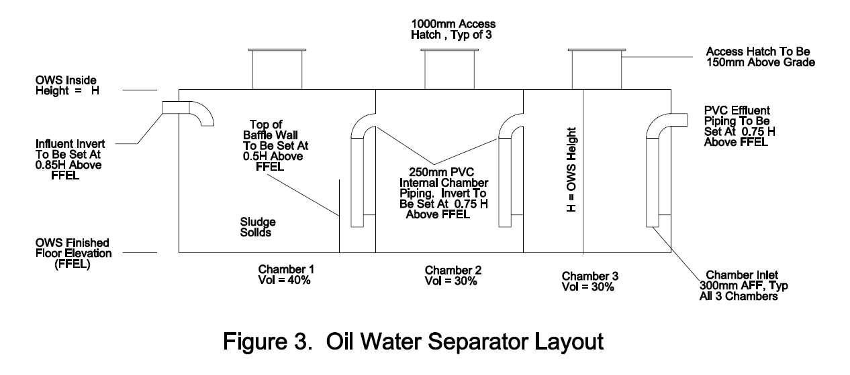

The first chamber traps floatables, oils, sand and other sediments. The second chamber traps oils which were entrained in with the water, and the third chamber is a polishing chamber. A majority of the solids will settle in the first chamber which should be periodically cleaned. The oils will also preferentially remain in the first chamber, but carryover will occur into the remaining chambers during high flow surges.

**10. Design Example**

Design an oil water separator for a vehicle maintenance facility with 3 hose bibs which are used for wash down. Each hose bib is rated at 0.5 L/s. Normally 1 maintenance bay will be rinsed at a time, but all three may be at the same time during a spill cleanup.

Average Flow = 1 * 0.5 L/s;

Required Volume for Average Flow = 30 min * 0.5 L/s * 60 sec/min = 900 L = 0.9 m3

Peak Design Flow = 3 * 0.5 L/s = 1.5 L/s

Required Volume for Peak Flow = 15 min * 1.5 L/s * 60 sec/min = 1350L = 1.35 m3

The required separator must have a minimum volume of 1.35 m3. Calculated Separator Dimensions:

Horizontal Velocity = 0.91 m/min, therefore

Depth x Width = 0.09 m3/min

0.91 m/min

= 0.1 m2

If assume Width:Depth = 2:1, then W = 2D and therefore 0.1 m2 = D * 2D. Depth = 0.22m and Width = 0.44 m

If assume Length:Width = 3:1, then L = 3W, and Length = 1.34 m

Calculated Separator Dimensions: D = 0.22 m, W = 0.44 m and L = 1.34 m

Calculated Separator Volume: 0.13 m3

A separator with dimensions of D = 0.25 m, W = 0.5 m and L = 1.4 m will meet the separator dimensional design requirements, but this separator does not meet the minimum AED separator requirements. Therefore, the separator required for this application would be D = 1 m, W = 2 m,

L = 3 m which would have a volume of 6 m3, and a detention time of 200 minutes at the average flow when using 1 hose bib, and 67 minutes at the peak flow when using 3 hose bibs.

**11. Central Vehicle Wash Facilities (CVWF)**

Facilities for the collection, treatment and reuse of runoff and recycled wash waters from vehicle wash facilities shall be designed in accordance with UFC 4-214-03. Separators designed using this document typically provide sedimentation, filtration, chlorination and oil water separation.

**12. Sludge Removal and Disposal**

Reliable sludge removal from the separation chamber is a frequent problem with both commercially available units and custom-designed separators. Currently, the most satisfactory method involves suction removal by installation personnel using equipment normally used for cleaning catch basins. This equipment is commonly referred to as a “vacuum" or "vac-all” truck.

**13. Guidance Documents**

The following documents provide additional guidance in operating and maintaining oil/water separators.

MIL-HDBK-1005/17 Nondomestic Wastewater Control and Pretreatment Design Criteria.

MIL-HDBK-1138 Wastewater Treatment System Operation and Maintenance Augmenting

Handbook.

UFC 4-214-03 Central Vehicle Wash Facilities, 16 January 2004.

**14. As-Builts**

Upon completion of installing the oil/water separator, The Contractor shall submit editable CAD

format As-Built drawings. The drawing shall show the final product as it was installed in the field, with the exact dimensions, locations, materials used and any other changes made to the original

drawings. Refer to Contract Sections 01335 and 01780A of the specific project for additional details.